**WRITE A MAP REDUCE PROGRAM TO REMOVE COMMAS PRESENT INSIDE THE DOUBLE QUOTES:-**

**DRIVER CLASS:-**

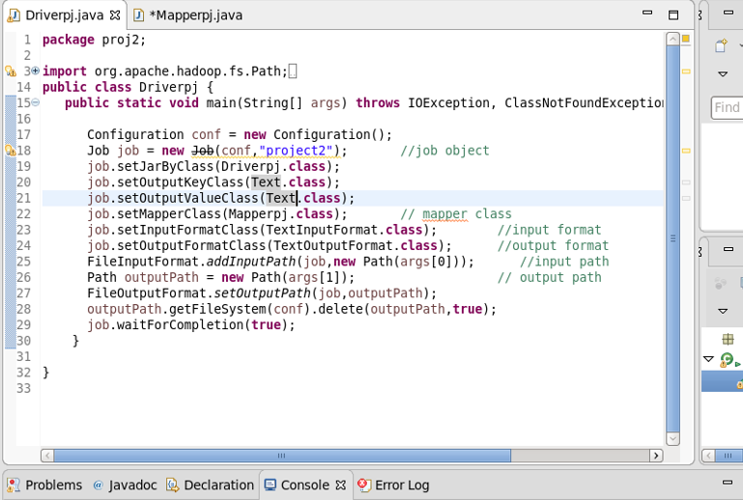

**MAPPER CLASS:-**

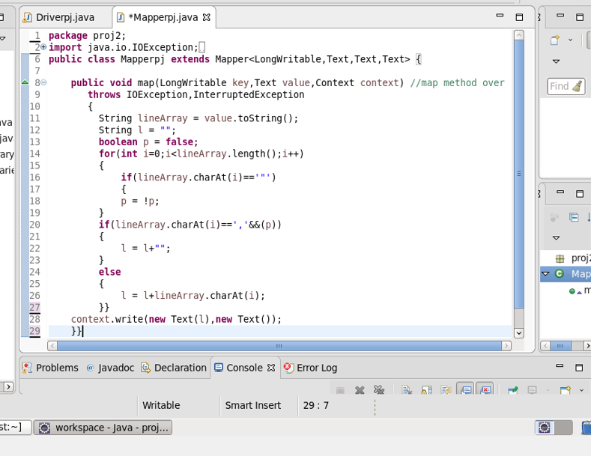

**RUNNING JAR FILE:-**

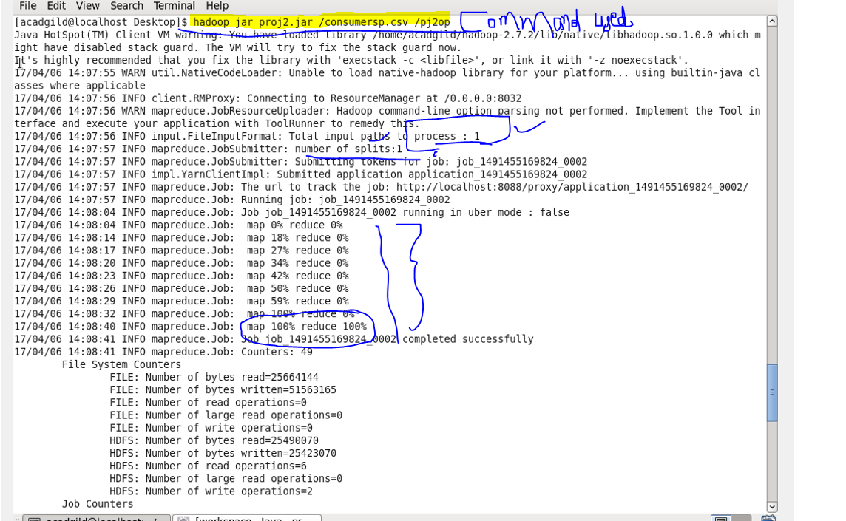

**OUTPUT:-**

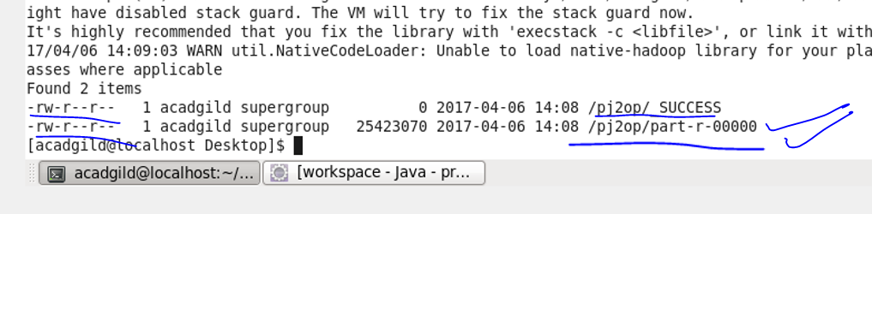

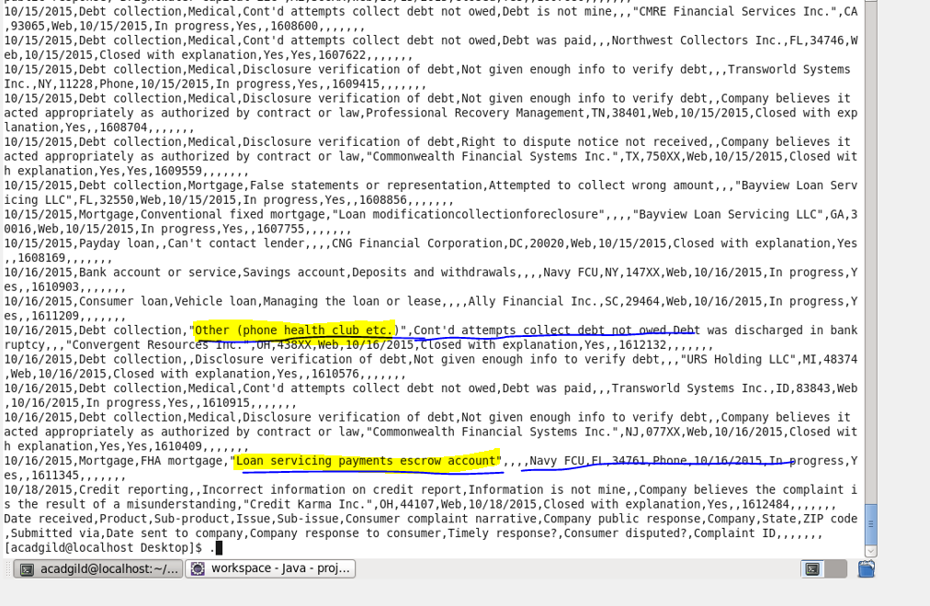

**TRANSFER THE OUTPUT FILE FROM HDFS TO LOCAL SYSTEM BY GET COMMAND:-**

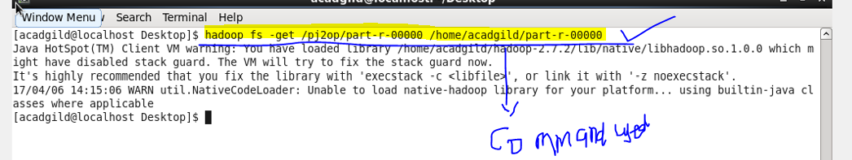

**APPLY THE PIG COMMANDS ON THE OUTPUT FILE, NOW OUTPUT OF THE MAP REDUCE PROGRAM ACTS AS INPUT FILE FOR PIG COMMANDS:-**

**1:-WRITE A PIG SCRIPT TO FIND NO OF COMPLAINTS WHICH GOT TIMELY RESPONSE:-**

**PIG COMMAND:-**

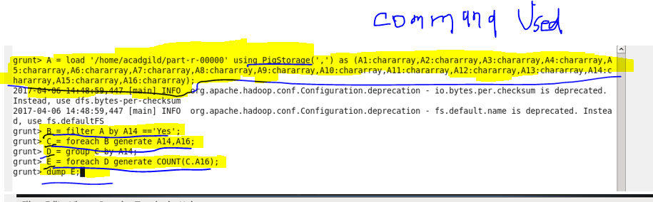

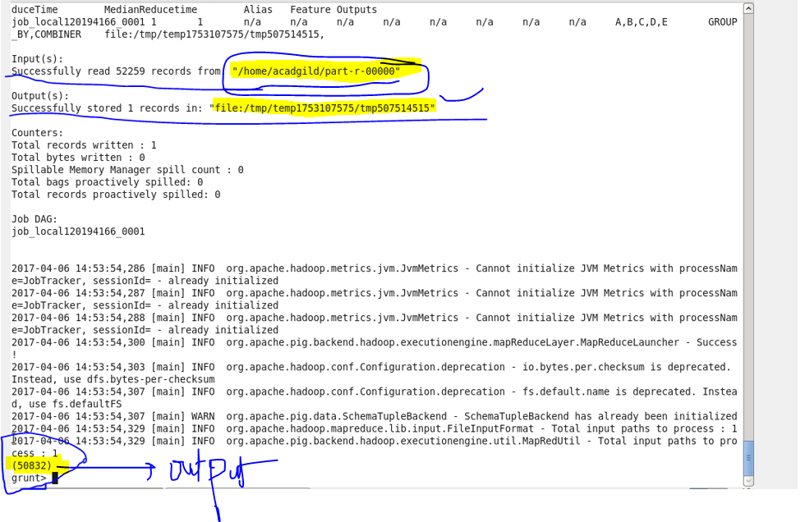

**2:-WRITE A PIG SCRIPT TO FIND NO OF COMPLAINTS WHERE CONSUMER FORUM FORWARDED THE COMPLAINT SAME DAY THEY RECEIVED TO RESPECTIVE COMPANY:-**

**PIG COMMAND:-**

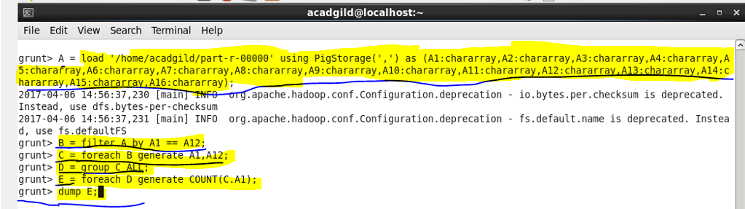

**OUTPUT:-**

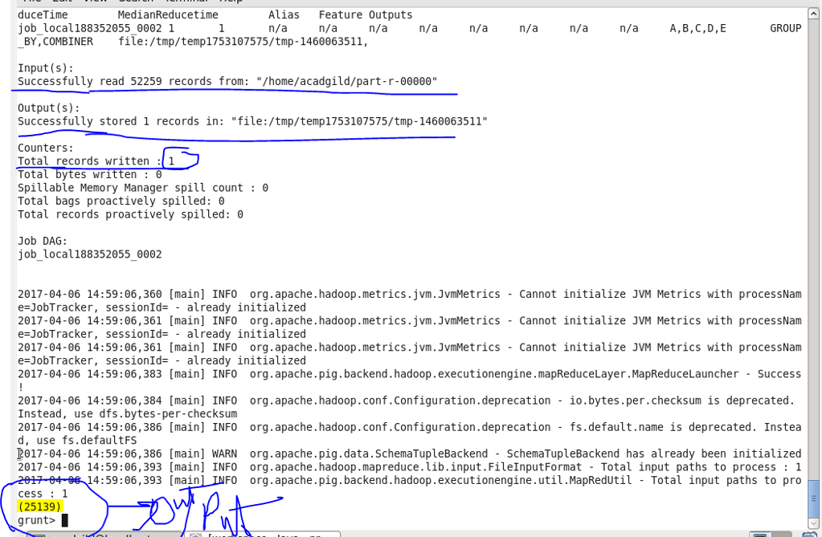

**3:- WRITE A PIG SCRIPT TO FIND LIST OF COMPANIES TOPPING IN COMPLAINT CHART (COMPANIES WITH MAXIMUM NUMBER OF COMPLAINTS)**

**PIG COMMAND:-**

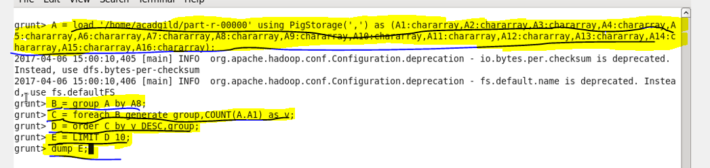

**OUTPUT:-**

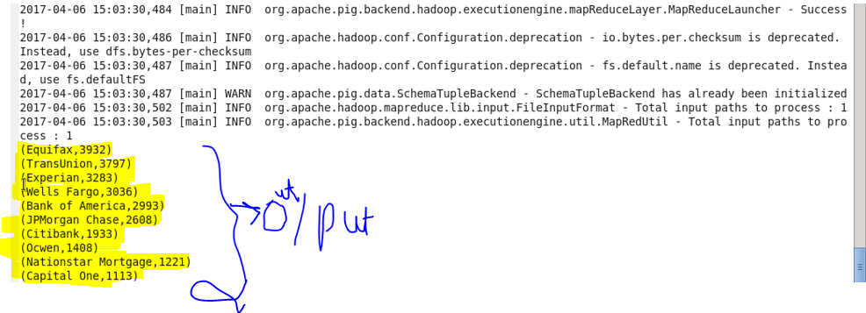

**4:-WRITE A PIG SCRIPT TO FIND NO OF COMPLAINTS FILED WITH PRODUCT TYPE HAS "DEBT COLLECTION" FOR THE YEAR 2015**

**PIG COMMAND:-**

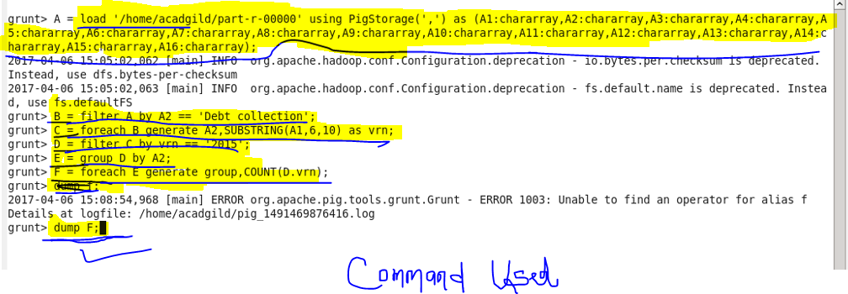

**OUTPUT:-**

